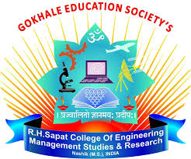

**Savitribai Phule Pune University**

**Gokhale Education Society’s**

**R. H. Sapat College of Engineering, Management Studies and Research,**

**Nashik - 422 005, (M.S.), INDIA**

**DEPARTMENT OF COMPUTER ENGINEERING**

**Third Year Computer Engineering**

**Year 2022– 2023**

**Roll No:**

**Name of Student:**

**Mobile No.:**

**official-Mail ID:**

**Seminar Title :**

**Seminar Guide :**

**Area of the Seminar:**

**Abstract (TNR Font 14)**

**(TNR font 12)**

**Introduction**

**Introduction:**

**Method/Algorithm**

**References**

1] Artificial Intelligence [online] Available: <https://en.wikipedia.org/wiki/Medicine_and_IT> Accessed on 05.02.2019 (For article)

2]<https://www.macmillandictionary.com/thesaurus-category/british/doctors-and-other-medical-and-health-specialists> Accessed on 05.02. 2019 (For visited website)

3]Dan Li , Wlliam Yang, Weida Tong, Renchu Gaun Survey on “Comprehensive Analysis of Pulmonary Adenocarcinoma In Situ (AIS) Revealed New Insights into Lung Cancer Progression” pp 5090-3050 March 2017 Accessed on 03.02. 2019(For Reference paper/Research paper /Journal)